|  |  |
| --- | --- |
| **Sankalp: Tours & Travel** | Abstract  This project is walk you through creating web application using flask framework supporting Python, SQL, HTML-CSS.  Sankalp Khavle  Flask App |

Requirements :

* Python 3.10
* Sql server (Xammp,MySQL)
* VS code editor

Installtion:

To run app flawlessly , install pip packages from vs code directly

* pip insatall pymysql
* pip insatall flask

& before running the flask app kindly create “flask-project” database inside a SQL with user_table & trip_table, You can simply copy paste the code for README.txt

Connections :

Using Flask, We can simply link all of them together. Firest of all we need to connect Python we the SQL using package PyMysql from we can create,insert and retrive data from our SQL server at backend.

For frontend, We need to connect Html and python using the flask module importing render_template,redirect and requests

1. To open the Web UI of the application, Run the base4.py file in VS code and paste the genrated Url in browser

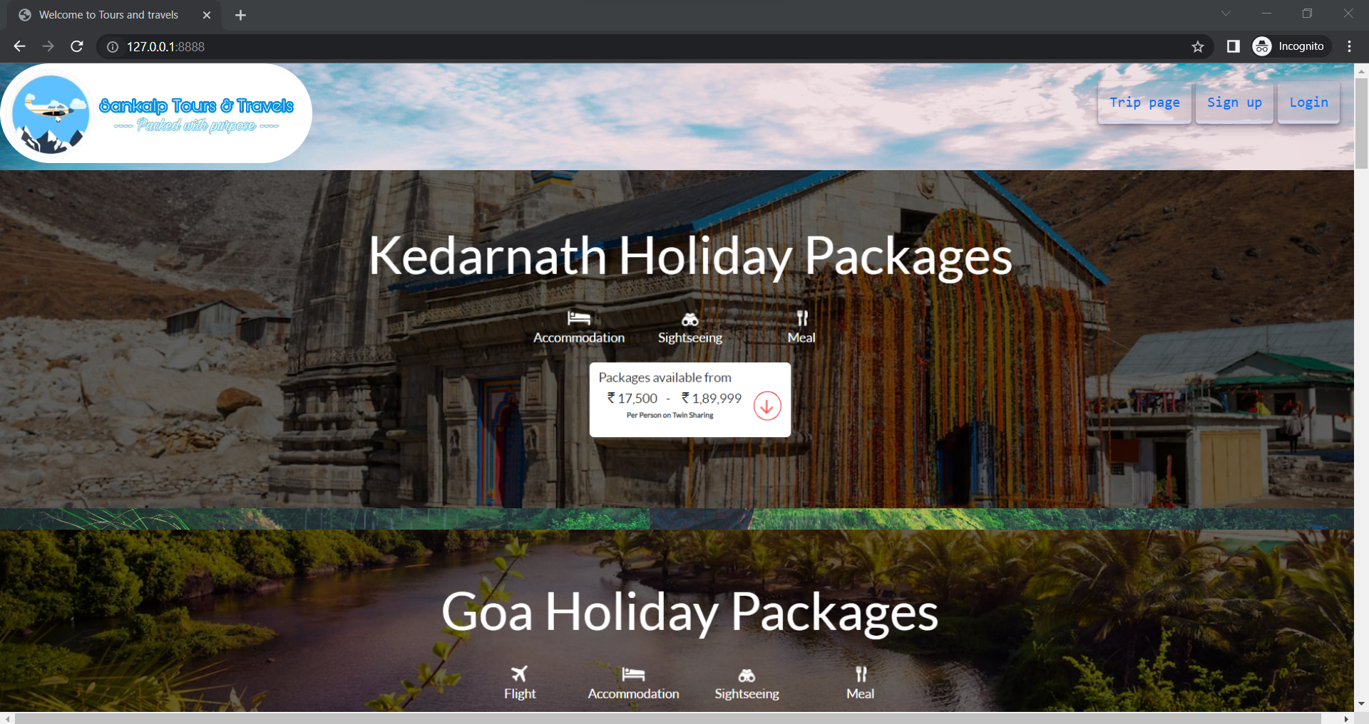

Click on any tour you wanted to go or simply click on Sign up to register yourself and if you are already registered click on login.. Note that if you already resgistered and Signup with the same details of email,pass and contact, it will redirect you to the login page. & clicking on logo between any page will jump you to the home page.

1. Register Yourself

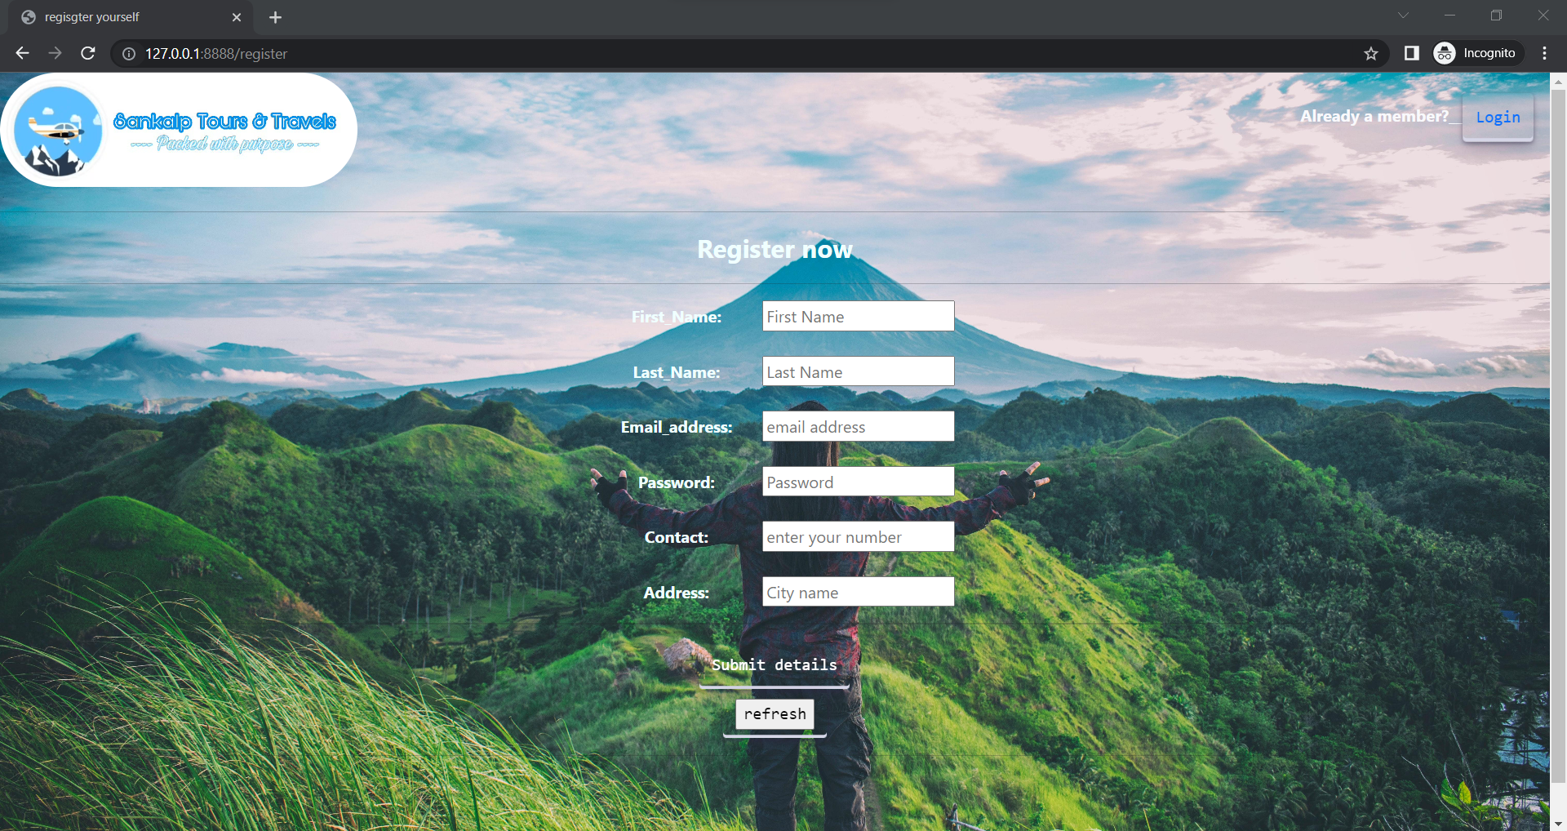

On register page, Enter your details and hit submit, Flask app will create your table using your First Name in SQL to store your data, if you are already a member, simply click on login to preview you profile and Tours.

1. Trip page

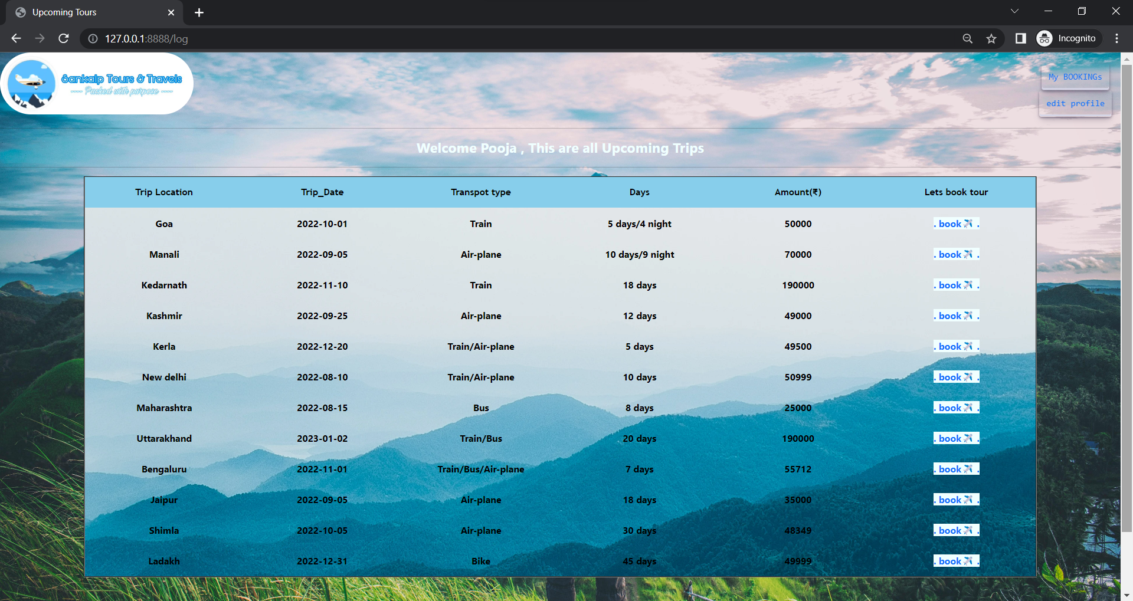

This all are the upcoming trips for you to book, clicking on book redirect you to the booking page. This all trips are retriving from the trip_table from SQL. If you wanted to check your booked trips you can simply click on “My bokkings”.

1. Booking page

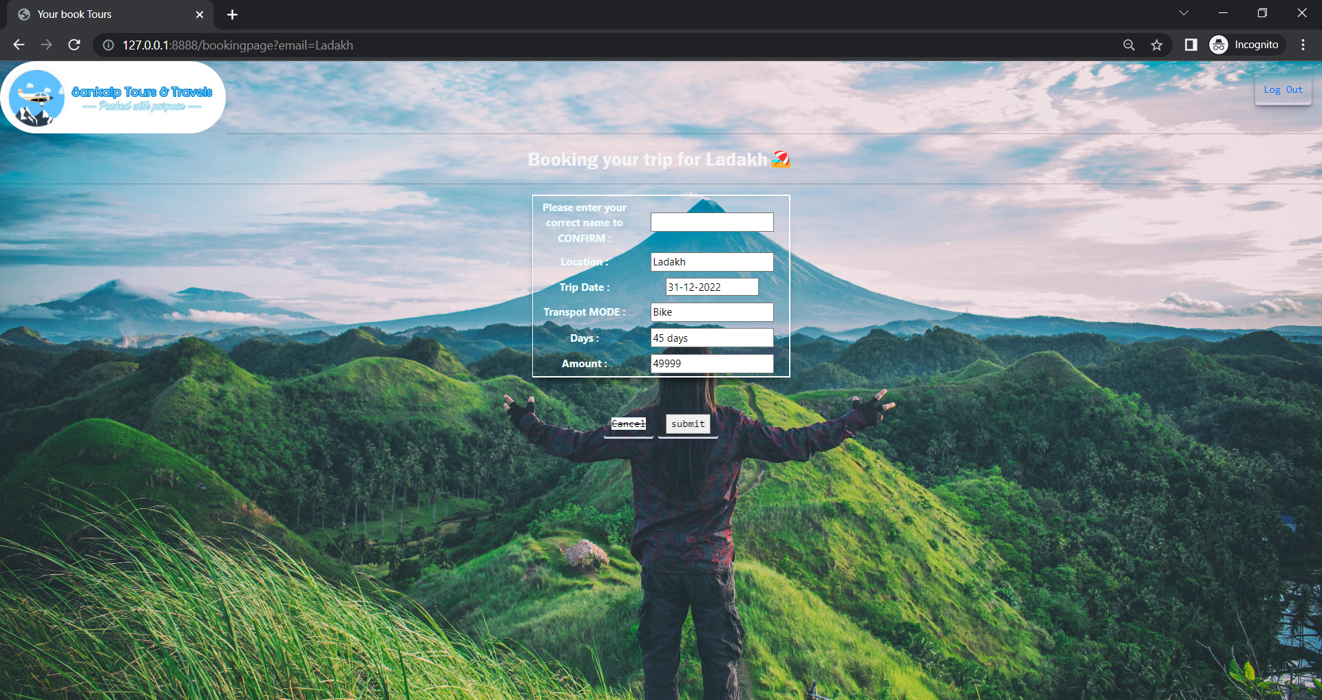

After clicking on book, it will redirect you to the booking page where you need to enter you correct name which you have used while signing up to add this trip to your table.

1. Mybookings

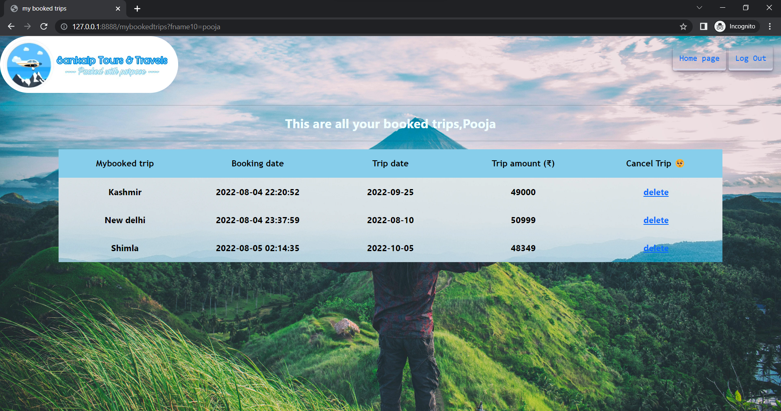

After booking that trip will added to your Bookings, You can simply review them clicking on Mybooking after login. We can simply delete the added trip by clicking on delete. It will remove the trip from your table too.

1. Edit page

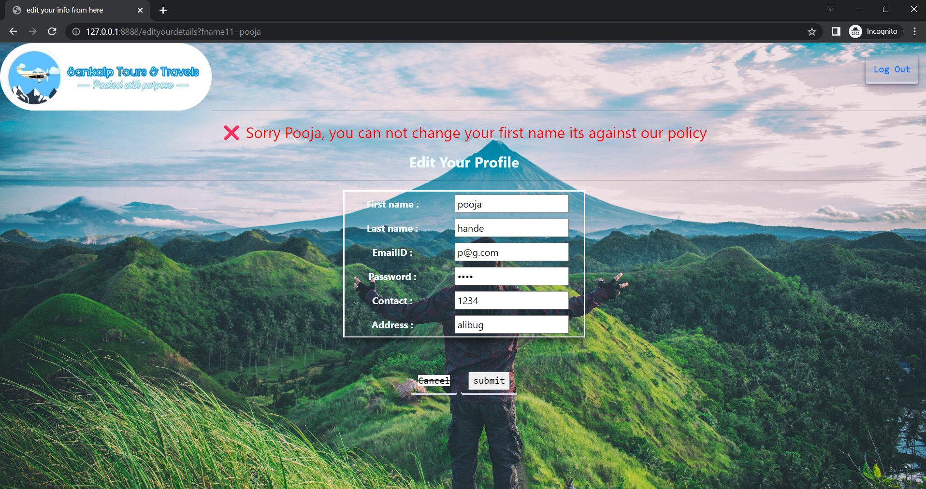

After login, if you need to change your details you can click on edit profile which will redirect you to the edit page where you can not change your First name as the same name table has been created to SQL server. While changing the email, pass and contact, the same you will need to use on the login page.

----Thank you----

